Dear:
I am interested in the Agile Coach position you are looking to fill in. I am a Certified Scrum Master and a PMP, with diverse experience, currently as a Agile Coach/Scrum Master at my current employer KOHLS Inc (IT department). I believe that the skills and experiences I have gained at this position make me an ideal candidate for the job of Agile Coach at your firm.
I have been a part of transitioning teams from Waterfall to Agile by introducing Agile across the board from Business to IT departments, by training their mindset and setting up a cadence. I adhere to the Agile principles and a preacher of Scrum focusing on my personal ‘no-wastage’ rule. I believe in team-work with clearly defined accountability and providing motivation with empowerment. As a successful Scrum Master, I thrive to make the team efficient and productive by allowing them to focus on their assigned tasks, while I work hard towards paving impediment free path leading to a quality product.
I conduct daily Scrums and enjoy holding Retrospective meetings after each sprint which allows the team to celebrate the success by identifying the strengths as well as acknowledging the weaknesses candidly and developing a plan for improvement.
I am confident that my experience as a Scrum Master and my people management skills qualify me for consideration. If you would like, I can provide you with current samples of my work. I have also enclosed my resume. I look forward to meeting with you and discussing my qualifications in more detail.

Sincerely,
Shazia Ibrahim
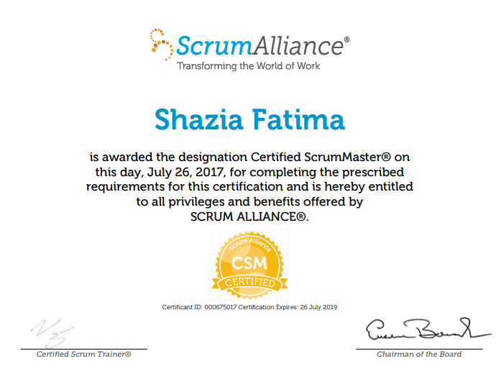
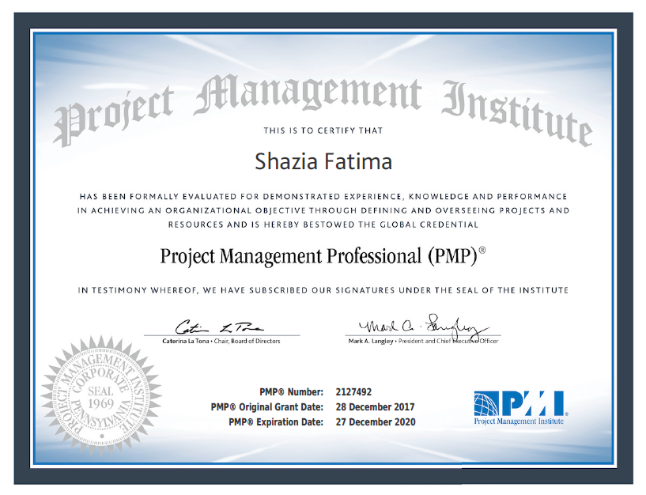

PROFILE
PMP/ Scrum Certified Delivery Manager. Goal-driven IT professional with diverse experience in P & C Insurance, Pharmaceuticals, Healthcare Management, Manufacture, Procurement and Logistics industries. Excels in complex fast-paced environments. Proven track record of meeting and exceeding project goals while maintaining highest quality standards. Outstanding organizational, inter-personal and communication skills.

EDUCATION |  |  | CERTIFICATIONS
- MBA - OKCU, OK- USA |  | - PMI- PMP
- Bachelors in Computer Applications - OU, A.P –India |  | - CSM – Certified Scrum Master
- PGDCA- Post Grad Diploma in Com App - India |  | - Six Sigma White Belt

SUMMARY
- Over 10 years of Industry experience as a PM/Delivery Manager/Scrum Master/BSA in complete project lifecycle, Design, Development & implementation of web based applications/SharePoint & BI. Extensive experience in Agile Development Methodology with in depth knowledge and understanding of business process analysis.
- Divers IT experience in sectors such as Operations, and Customer Relationship Management for P & C Insurance, Healthcare, Pharmaceuticals, Supply Chain management, Claims management business, Logistics verticals.
- Combines technical and analytical aptitudes with problem-solving strengths to manage the requirements and deliver the projects to on-time, on-budget and high-quality completion.
- Exceptional focus on customer service and passion for working in a customer-facing role, while building partnerships with stakeholders across the company.
- Work with product owners to groom the backlog and plan sprints. Track, Escalate and remove impediments. .
- Improved team velocity by assisting in capacity planning into sprint planning sessions.
- Resolved several conflicting requirements issue by creating and utilizing a professional network of Product Owners and Technical Leads between Business Units and Business Systems tam.
- Introduced and implemented Agile Scrum Methodology with respective business units to improve communications between Application support team and Business; to provide more transparency across various departments; and to obtain great business value with short turnarounds.
- Experience with various diverse projects including but not limited to web application developments,migrations, pilot programs, cloud services, AWS.
- Facilitated Release Planning, Sprint Planning, Backlog Grooming, and Retrospective meetings to build good working relationships.
- Collaborated with members of the Product, Business (Accounting, Admin Services, Capital Markets) Teams to develop and maintain Product Backlogs.
- Coordinated in weekly estimation meetings to provide high-level estimates (Story Points) for backlog items.
- Expert in Risk Response Planning, Risk Identification, Mitigation and Issue Resolution.
- Monitored the development progress throughout each sprint to ensure project was within scope.
- Worked with business users to incorporate UX best practices, create mock-ups to ensure a more comprehensive and innovative approach.
- Experience with various ITSM applications following ITIL guidelines.
- Developed crucial functional requirement specifications, creating detailed use cases and process flow diagrams to support functional specifications.
- Conducted meticulous GAP analysis while successfully reengineering key business processes to increase operational efficiency and alignment of business unit objectives.
- Guided in deriving ROI and extensive cost - benefit analysis to support system and process changes.
- Successfully guided the development teams through transition from waterfall to Agile development.
- Removed impediments and protected team members from interruptions and distractions to maximize productivity.
- Worked with Senior Management, Business & Release Management to understand the vision of the product, prioritize and develop software release planning.
- Communicated the progress to senior management thru 'Burndown Charts'. Monitored the Quality thru metrics and mentored team thru the project management processes.
- Coached and empowered new team members to self-organize and grow cross-functionally.
- Responsible for planning, execution to ensure delivery on time by managing the on/offshore teams.
- Coordinated and managed code releases to ensure smooth release & sent release notes.
- Proficient in using TFS- Microsoft® Visual Studio® Team Foundation Server 2010 and JIRA

PROFESSIONAL EXPERIENCE

KOHLS, Menomonee Falls WI Role: Agile Coach/ Scrum Master/ Project Manager
Duration: May 2018 to Present
Projects:
Return Services Project and AMZ Returns : Streamlining the Returns process at KOHLS departmental stores by providing customer friendly ways.

Responsibilities:
- Delivered projects and products using the appropriate agile project management methodology, learning & iterating frequently.
- Worked with the Product Manager to define the roadmap for any given product and translate this into user stories.
- Led the collaborative, dynamic planning process – prioritizing the work that needs to be done against the capacity and capability of the team.
- Collected the ticket metrics, used tools like Cumulative Flow Diagram to provide demand pipeline visibility.
- Extensively used Service Now and JIRA covering a wide array of application lifecycle tasks, from project planning and user story creation, work item tracking, to version control, to testing and deployment.
- Experience with TFS for release management.
- Conducted backlog reviews, planning poker sessions, sprint planning, customer reviews.
- Transitioned the teams from Waterfall to Agile. Walked through the Definition of Done and provided guidance as an agile coach.
- Initiated product backlog grooming and pruning and guided PO in developing user stories with clear acceptance criteria by following the Epic>Feature>User Story hierarchy.
- Provided weekly status to internal and external stakeholders.
- Conducted all the Sprint ceremonies in timely order to make sure the team is on track.

Trinity Industries, Dallas TX Role: Scrum Master/ Delivery Manager/Business Systems Analyst
Duration: Jan 2014 to April 2018
Projects:
EOS Upgrade project, TAS-EOS Interface project, Invoice Designation project, Revenue Pooling project, Investor Repairs-Accounting project, Customer Portal Enhancements, Several BI development, Several Reporting Projects.

Delivery Manager Responsibilities:
- Occasionally facilitated matrix-management in a multidisciplinary team.
- Ensured all products are built to an appropriate level of quality for the stage (test/UAT/Staging/production).
- Established a solid relationship with the Product Owners at the tactical level, ensured the tickets were created and synchronized with the electronic ticketing system (TSM).
- Participated adn facilitated sprint and release planning, daily stand-ups and retrospectives.
- Managed impediment backlog and motivated team members to identify necessary action.
- Extensively used Microsoft Team Foundation Server (TFS) covering a wide array of application lifecycle tasks, from project planning and user story creation, work item tracking, to version control, to testing and deployment,.
- Coached new team members in Agile adoption and TFS usage.
- Worked closely with teams to increase efficiencies and decrease waste.
- Developed and maintained stakeholder communication plan to inform stakeholders of deployments.
- Presented to executive team and other departments the current business needs, order of priorities and expected delivery dates for products that will fulfill the business needs
- Managed burndown charts and motivated team members working toward goals.
- Advocate of scrum framework and company vision within organization.
- Maintained storyboards, organized charts within TFS and influenced best practices to team.
- Prioritized product backlog for grooming and sprint planning while product owner was absent
Business Analyst Responsibilities:
- Converted the high level requirement to a User Story in Team Foundation Server (TFS) and followed through to gather detailed business requirements.
- Created and assigned tasks for ‘Requirement Gathering’, ‘Development’, ‘Testing- System testing, UAT’ and ‘Deployment’.
- Managed the user story throughout the development life cycle.
- Developed detailed requirements, supporting business rules and establish acceptance criteria to be qualified as a user story.
- Regularly reviewed the business demand pipeline/enhancements to prioritize and stack rank based on the preferred release cycle.
- Created wireframes for KPI reports and mock ups for EOS UI enhancements requests using Axure prototyping tool.
- Interviewed various stakeholder to prepare As-Is and To-Be business process flow.
- Developed the end-to-end high level business process flow diagram using Mega modelling suite, to capture to the business processes from inquiry from a potential/ existing customer to the order placement.
- Identified various entities and the attributes within the application and developed a master E-R diagram along with detailed auxiliary E-R diagrams.
- Facilitated several Joint Application Development (JAD) workshops to drive out business requirements. Used rapid
prototyping techniques to get design input from all parties, resulting in zero follow on work after the release to production.
- Managed the insight and opinions of multiple stakeholders and helped to ensure all stakeholders agreed with the current scope and roadmap of the product.
- Conducted user interviews to help identify and understand different process for each user while simultaneously identifying their pain points.
Quality Assurance Analyst Responsibilities:
- EOS Application: Developed Test cases in TFS and Test Strategy to perform testing. Identified in charge of several functional testing efforts for major releases each resulting in no critical bugs released into production. Conducted through system testing and led successful UAT.
- TAS Application: Conducted testing and also provided relevant guidance to the designated QAs as needed.

PRIMUS Global (Consultant) Role: Project Manager/Scrum Master/Sr.BSA
Trinity Industries, Inc. Dallas, Texas Duration: July 2012– Jan 2014
Projects:
Financial Statements Tracking project, Competitive Market Intelligence project, Several BI enhancements, Reports Replacement Projects.

Business Analyst/PM Responsibilities:
- Gethered project requirements using various techniques from different user groups.
- Assited scope definition by forming consensus with the project stakeholders.
- Analyzed the assumed gaps in the business process flow for Credit monitoring for potential and existing customers
- In lieu with the high level requirements conducted JAD sessions with SMEs to cover both business and technical aspects.
- Captured the as is flow steps and conducted AS-IS analysis with detailed business process modeling. Based on the business requirements conducted TO-Be analysis with detailed business process modeling to present the future state
- Developed BRD for including the BPM, Developed detailed System Analysis and Design document with technical and design specifications.
- Conducted research on identified Interface issues between EOS and TAS applications
- Worked closely with the developers in identifying the triggers for issues and finding solution to fix these issues.
- Analyzed the potential solutions for and possible impact it may have on business process flow
- Developed and supported Extraction, Transformation and Load process (ETL) using Ab Initio to populate the tables in Data Warehouse and Conduct>IT plans to manage the jobs in production (trigger jobs, restart ability and recovery of jobs from failure).
- Created several Wireframes for complex Reports, Developed a technical flow of information in order to present the reporting process flow.
- Discuss the report migration process, retiring unused reports, enhancing existing report framework and better usage options.
- Conducted onsite and online client review and walkthrough sessions for the approval and sign offs of the BRD, Design document and UAT document
- Provided project progress updates to the stakeholders in the status meetings, Captured MOM as needed.
- Using Axure Wireframe –Prototyping tool, created several mock-up screens as per the requirements making it suitable for the Agile methodology being followed for this release.
- Conducted analysis on leveraging existing custom fields in the application as oppose to creating new.
Configuration Analyst Responsibilities:
- Participated in workshops with EOS vendor D+H to gain UI configuration knowledge.
- Worked with Business Validation Rules in the application to support the designed business workflow for different programs such as Direct Sales, Leasing and Management Services of railcars.
- Performed UI configuration in PreUAT and UAT environment
- Performed UI configuration as per the requirements and participated in providing implementation support for report building.
Quality Assurance Analyst Responsibilities:
- Wrote several end to end test cases for each entity and various user roles that participate from the customer inquiry to the order placement.
- Conducted system testing, regression testing in each environment.
- Performed the role of Lead Tester for complete manual testing including writing test cases in HP- QC version 10.0, creating bidirectional RTM, executing tests and collecting signoffs.
- Logged identified bugs in the vendor bug tracking site, followed up with status calls and bug resolution validation.
- Created test data for regression testing. Using the test data conducted several rounds of testing attempting to replicate the bug in different scenarios.
- Tested the fixes thoroughly to make sure implementation of a solution for one issue does not hinder the other.
- Developed a through bidirectional Requirements Traceability Matrix (RTM) including the traceability to the testing phase
- Prepared Test Case Document strategizing the testing phase and Test Case matrix wrt each requirement.
- Conducted manual testing and logged bugs/ issues in HP Quality Center.
System Admin Responsibilities:
- Performed the role of system admin for EOS application by triaging the incident tickets.
- Provided resolution to various severity tickets wrt EOS application in production environment.
Accolades:
- All above deliverables were highly graded by the Client, with the overall effort receiving written commendation by the project’s executive sponsor.

GalaxE.Solutions. Somerset, New Jersey Role: Lead BA/ QA/PE/CR Consultant
Duration: Nov 2007– Jun 2012
Projects/ Locations:
- Aetna Gaps Implementation, Platform Consolidation. | - CVS Caremark - Richardson, TX
- e-Prescribing, Product Portal development, MS Project implementation. | - CVS Caremark TheraCom - Gaithesberg, MD
- Independent Verification&Validation. | - CVS Caremark - Woonsocket, RI
- Independent Verification&Validation, Production Issue RCA. | - CVS Caremark - Deerfield, Ill
- Event Handling Automation. | - CVS Caremark - Philadelphia, PA
- Rating Service Implementation, IV&V. | - Liberty Mutual - Somerset, NJ/ Portmouth, NH
- J2EE migration. | - ACCREDO - Somerset, NJ/ Memphis, TN
- Legacy Migration, IV&V. | - Medco Pharmaceuticals - Franklin Lakes, NJ

Business Analyst/PE Responsibilities:
- Developed Business Requirements (BRD) and Functional Requirements (FRD) Documentation; facilitated their review and signoff process by the business, operations and technical stakeholders.
- Participated in all phases of Software Development Life cycle (SDLC).
- Surveyed current (AS-IS) business and technology environment, Analyzed business processes and developed proposed (TO-BE) business process flows.
- Conducted JAD sessions with cross-functional users to collect the requirements simultaneously made use of various requirements gathering techniques as deemed necessary.
- Developed use-case model and use-case diagrams in UML, augmented and enhanced existing use-case.
- Translated business requirements into domain and data models, developed process decomposition diagrams, entity relationship diagrams, dataflow diagrams and state diagrams.
- Defined, analyzed and modeled system's business domain. Developed domain models for each application module in MEGA modeling tool.
- Played key role in identifying performance "pain points" and gathering SLA requirements through surveying business- and IT stakeholders, and interacting with SME’s for Auto and Property Underwriting line of business.
- Perfromed modeling of the Business Processes and corresponding Business Domains, created diagrams using MEGA Modeling suite. Utilized ERwin Modeler for domain model diagramming.
- Interviewed business and IT personnel to validate developed business models, formally documented existing enterprise operational environment: workflows, software architecture, and information architecture.
- Produced Service Domain analysis and Service Domain modeling documentation utilizing CA ERWin Data and Process Modelers.
- Performed analysis of Productions issues both front end and backend apps. Made suitable recommendations.
- Analyzed existing functionalities of the RxClaim and QL Formulary Systems and perform detailed gap analysis between the systems of various financial, planning and distribution sectors of supply chain management.
- Identified and documented the functional activities, data repositories, data relations, data mapping and dependencies of RxClaim and the QL formulary Systems.
- Developed a Proof of Concept (POC) for the platforms consolidation approach to demonstrate the QL Formulary process to support the data, rules, statuses and routines of the adjudication process within the RxClaim system.
- Performed data mapping to support the POC developed between RXCLAIM and QL formulary system
- Analyzed and provided data to support the functional GAP analysis between QL and RxClaim Systems
- Provided data to support synchronization between the QL formulary and the RxClaim Systems
- Developed feasible technical approach to support QL Formulary data mapping with that of RxClaim Formulary system
- Quality Assurance: For the ECS 5 Project, verified conformity of technical documentation produced by the project team to the GalaxE High Quality and Best Practices standards.
- Defined Performance testing objectives, provided test case specifications, developed detailed test plan.
- Designed test cases and prepared test data to be used during stress and endurance testing of the system.
- Developed test scripts (HP Performance Center - VuGen). Participated in Performance testing using HP Performance Center - LoadRunner.
- Analyzed and aggregated test results, including system capacity and stability analysis.
- Developed a through bidirectional Requirements Traceability Matrix (RTM) including the traceability to the testing phase
- Reviewed use case artifacts and completed their analysis for testability. Through use case analysis, created detailed activity and interaction diagrams to identify critical test cases and test scenarios.
- Organized and managed the current state analysis phase; developed a complete set of Specialty Drugs “as-is” business process models (BPM), from intake to distribution; worked with the client teams in Rockville, MD, Richardson, TX and RI.
- Documented and distributed MOM in timely manner.
- Supervised and managed a team of two Business Analysts on various projects and mentored as needed.
Quality Assurance Analyst Responsibilities:
- Developed Test Strategy Document (TSD) and Test Plan Documents (TPD), including Test Case outline and traceability; organized their review and approval
- Experience with SQL databases and executing SQL queries.
Project Coordinator Responsibilities:
- Performed routine project management activities: from project planning through control and execution (progress monitoring, status review, phase gate review) to closing
- Played advisory role assisting project manager in defining the scope of the project with respect to BP modeling and Re-platforming of the application.
- Assisted the project manager in applying concepts and techniques of the development resource utilization analysis; scrutinized existing Demand-Capacity Model and suggested several enhancements to it; extended metrics of resource allocation, tracking and optimization
- Provided assistance in preparing Project Charter in accordance with Client’s SEP standards.
Client Relationship Manager Responsibilities:
- Facilitated in presentation of the analysis to high level management for approvals and sign off and received favorable feedback.
- Developed great client relationship by maximum exposure to the client environments on-site, utilized opportunities to enhance client-facing skills by working to arrive at coherent understanding of the project objectives, and resolving usual client-consultant challenges
- Facilitated adoption of the SEP and GalaxE BP methodologies at RxSpecialty, ProCare CVS|Caremark Specialty Pharmacy subsidiary. Accomplishments during continuous, two-month onsite presence at client’s site in Pittsburgh, PA
- Closely collaborated with client’s business analysis group to deliver the BRD and FRD documents; mentored junior BA members.
- Significantly improved client relationship while managing the challenges of understanding and compliancy with SEP of client’s various development teams. Received highly positive feedback from the client
Third Party Vendor Management Responsibilities:
- In collaboration with the third-party vendor LogiSolve LLC, developed future state BPMs that facilitated business and functional requirements elaboration; that included revision and rectification of the project scope document (PS) initially provided by the vendor.
- Reviewed and provided detailed recommendations for the use case model (UCM) supplied by the third party contractor.

Claimetrics. Oklahoma City, OK. Role: CR-level I
Project: Insurance, Claims, absence & liability. Duration:May 2007 – Jul 2007
Responsibilities:
- Helping the supervisors with Workers compensation claims by updating information on IVOS application.
- Completed representative assignments.
- Managed CR with Payor, Provider and Patients.

Oklahoma City University. Duration: Jan 2004 – Jul 2007
Graduate Assistant to Dir of International Relations
Responsibilities:
- Process admission applications and documents. Reply to all enquiries through emails.
- Enter new student information before uploading into university mainframe. Provide informational support to students.
- Facilitate maintenance of student records. Provide assistance in student registration and enrollment.
- Assist director during university recruiting seminars. Update and maintain prospective student database in Recruitment plus.
- Scheduling and hiring drivers for student pickup at airport. Maintain and update records in excel. Receive the application fee and other deposits and update records.

TOOLS & SKILLS:

Modeling Tools: | MS Visio, MS Excel, MS Power Point, Mega Modeling Suite, ERwin Model Designer, Serena Prototype Composer, Eclipse modeling framework (EMF) Lombardi Blueprint, Lombardi Teamworks, Axure- Wireframes Prototyping tool, Pencil prototyping.
Applications/ ALM /Databases: | TAS, EOS, APMCAS, QL, HP Performance Center. HP Quality Center, , Swing for Eclipse GUI design framework, HP Sitescope, HP Diagnostics, HP Real User Monitor (HP RUM), Tableau.  HP Business Availability Center (HP BAC), MS Team Foundation Server.  MS Access, SQL Server, BPCS/AS 400
Modeling Skills: | Business Process Model, Flow Chart, Activity Flow diagram, Data Flow Diagrams, UML – Use Case diagram, Sequence diagram, Activity diagram, Data Modeling, Domain Modeling, Entity Relationship diagram, Gantt Charts, Burndown Charts.
Business Skills | Prepare and facilitate executive presentations, assemble and analyze complex reports.  Research and Interpret IT, marketing, and healthcare business research data to aid in Competitive Market Intelligence.  Project Management – Planning, Estimation, Resource optimization, Business Demand Delivery,
Inter-Personal skills | Equally comfortable as team leader or contributor.  Solution focused, Detail-oriented as needed, with great follow-up skills.  Independent thinker, exercising best judgment and awareness of environment limitations with a can-do attitude. Keen to share knowledge and expertise, to provide training and set technical direction when required. Interact with groups and individuals from various professional backgrounds and act as a liaison. Excellent interpersonal and communication skills.

MEMBERSHIP
IIBA-International Institute of Business Analysis PMI- Project Management Program Scrum Alliance

REFERENCES: Available upon request.

